Thanksgiving
is a holiday
in the month of November.

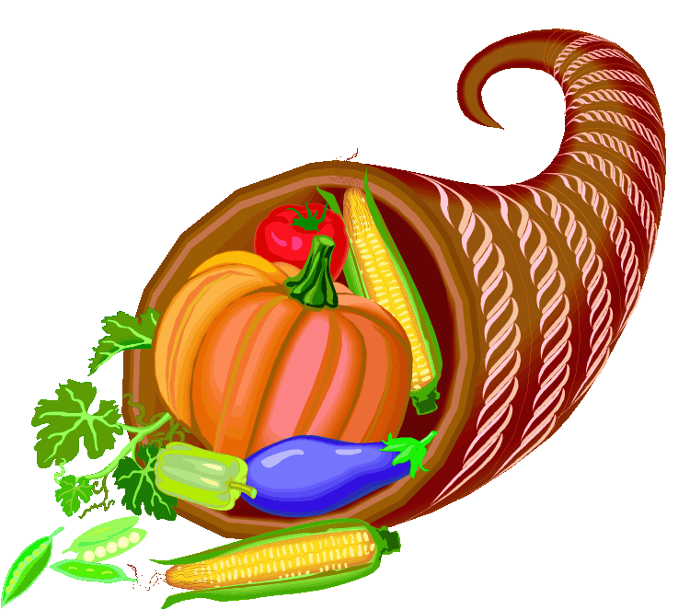

At school, we learn about
the first Thanksgiving which
happened in America in 1621.
Pilgrims and Native Americans joined together in a feast
to celebrate their first harvest
in the new land.
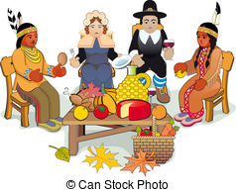

Teachers might have lots of
special snacks made with pumpkin.
We might even get to cook!
My teacher will help me if
I need help.

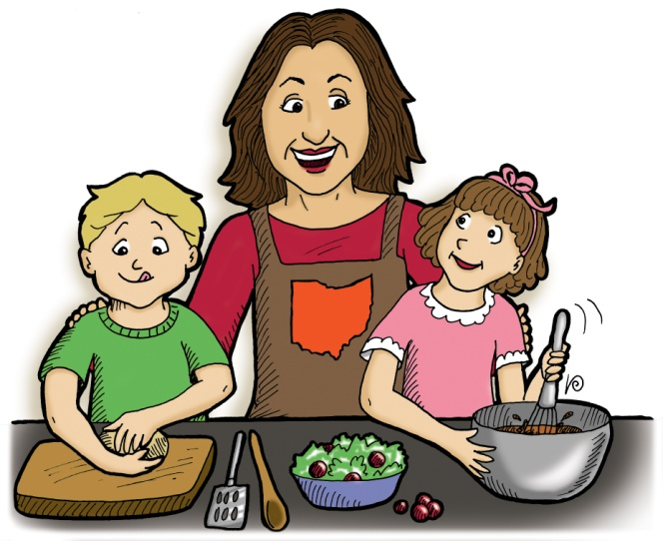

We might wear pilgrim hats or
headbands with feathers when
we go to the cafeteria.

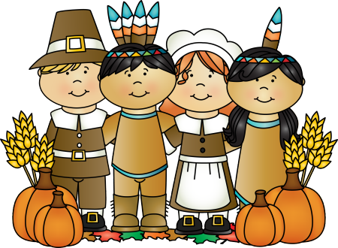

It’s okay if lots of people look at me while I am wearing my hat
or headband.
They will not be having weird thoughts.
They will think that I look happy.
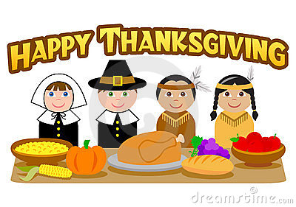

Sometimes, parents get
to come eat lunch with us
at school to help celebrate Thanksgiving.

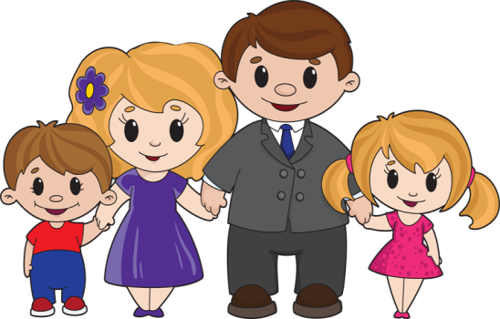

If my mom or dad cannot come, it’s okay. I can still sit with my
friends during lunch.

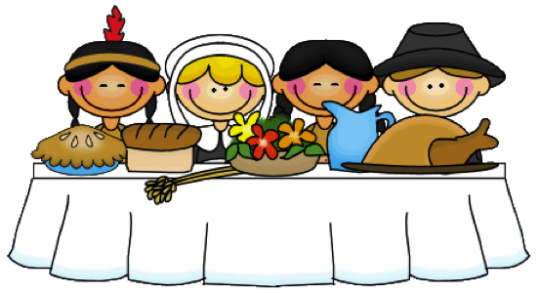

We will have turkey and dressing
with cranberry sauce.
We will also have
pumpkin pie!

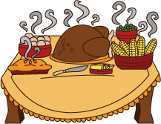

If I really do not want to
taste of something new,
I can just say,
“No, thank you.”

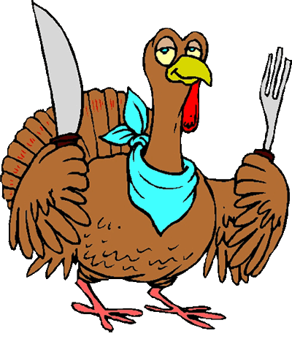

Each family has their own
special traditions
for Thanksgiving.

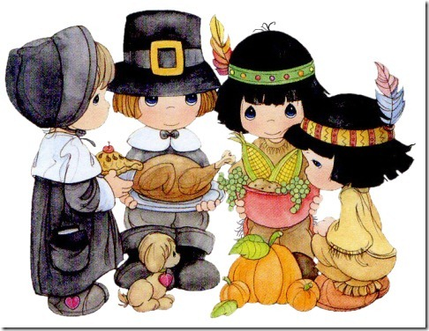

When my family gets together
to celebrate Thanksgiving,
I will try my best to
have nice manners.

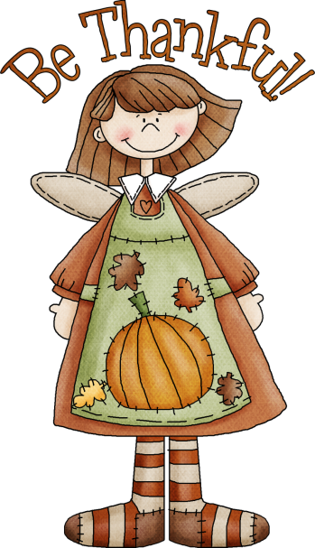

I will remember to stay calm
and just say,
“No, thank you,”
if I do not want
to taste of something new.

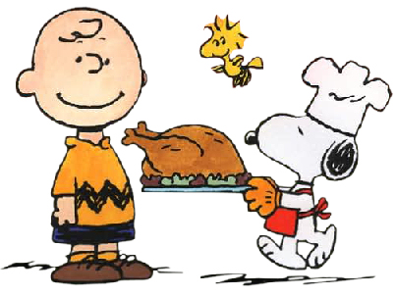

If it gets too loud,
I can tell my mom or
dad that I need a break.

I will try my best to
stay calm
and ask for what I
need in a nice way.

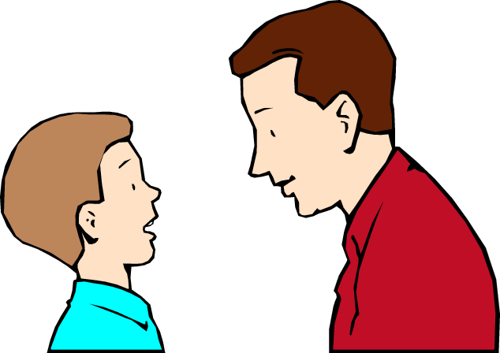

Thanksgiving at school
and with my family
is a lot of fun!

